**L I T E R A C Y B R I D G E ’ S**

**Talking Book**

**U S E R M A N U A L**

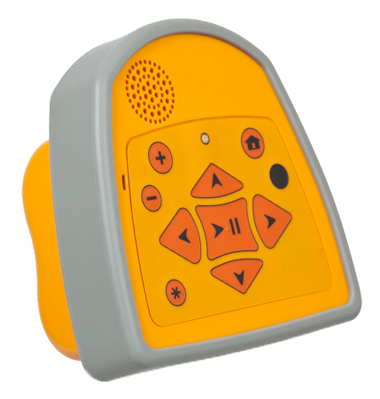

# Contents

Contents 2

Learning To Use A Talking Book 4

Basic Tasks 4

How to turn the device on and off 4

How to find the Welcome Message 4

How to listen to a message 5

How to move within a message, pause, and change the volume and speed 5

How to record a new message 5

How to listen to helpful tips about the device 5

How to record feedback about a particular message 6

How to answer the survey question about a particular message 6

How to remove a message 6

How to copy a message from one Talking Book to another Talking Book 6

How to add a message to your “Favorites” category 7

How to take a multiple-choice quiz 7

How to use “audio hyperlinks” to hear the definition of a word when a message is playing 8

Advanced Tasks 8

How to copy all messages within a category to another device 8

How to remove a category or remove all messages within a category 9

How to copy a special selection of messages from one device to another device 9

How to change the order of the messages in a category 9

How to change the order of the categories on a Talking Book 10

How to change the language of a Talking Book 10

How to copy user feedback messages from another Talking Book 10

How to update a Talking Book while also copying its user feedback and statistics data 10

Using the Expert Mode 11

How to duplicate one Talking Book from another Talking Book 11

How to translate the operating system instructions into a new language 12

How to update one or more instructions in the operating system 12

How to give a new language from one device to another 13

How to change the order of the system languages on a Talking Book 13

Configuring a Talking Book Using a Computer 14

Basic Tasks 14

How to install the Audio Content Manager 14

How to put the Talking Book into USB mode 16

How to add messages to the Audio Content Manager from a device 16

How to sort and filter messages by category, language, or keyword 16

How to listen to a message in the Audio Content Manager 17

How to edit the title and other message properties 17

How to copy messages from the Audio Content Manager to your computer’s desktop 17

How to add messages to a device from the Audio Content Manager 17

How to delete messages from the Audio Content Manager 17

How to view message usage statistics and survey results 18

Advanced Tasks 18

How to create an outbox folder 18

How to reformat a Talking Book and apply a new operating system 19

How to add a category to a Talking Book 21

# Learning To Use A Talking Book

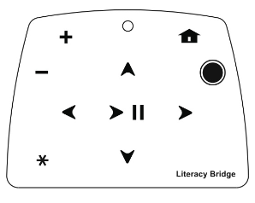

**Center button** – Pauses or starts a recording. Also turns device on. *Hold down to turn device off.*

**Home** – Returns to the “Welcome” message.

**Left arrow** – Changes categories. *Hold down to repeat the last few seconds of a message*.

**Right arrow** – Changes categories. *Hold down to skip ahead through a message*.

**Down arrow** – Changes messages within a category.

**Star** – Starts or stops recording a new message when you are in a category. *Hold down at startup to connect with a computer.*

**Plus sign** – Increases the volume. *Hold down to play messages faster.*

**Minus sign** – Decreases the volume. *Hold down to play messages slower*.

**Black circle** – Selects an option or presents options for the message or category. *Hold down to change languages.*

**Up arrow** – Changes messages within a category. *Hold down to enter “expert mode”*.

## Basic Tasks

### How to turn the device on and off

* To turn the device on, press the center button .
* To turn the device off, hold down the center button  until you see a red light and hear a beep. The device will turn off automatically when not in use.

### How to find the Welcome Message

The Talking Book always begins with a “Welcome” message followed by the first instruction for listening to a message (see below). To return to this “Welcome” message at any time, press the home .

### How to listen to a message

1. The messages on the device are organized into categories (for example, agriculture, health, and education). To scan through the categories, press the left arrow  or right arrow .
2. When you have found the category of your choice, press the up arrow  or down arrow  to listen to the messages within that category. These buttons allow you to circle through all of the messages in a category.

**Note:** When listening to a message, if you hear a ringing sound and the red light flashes, you can press the black circle to hear more about the topic or word that is mentioned just after the sound (see “audio hyperlinks” below).

### How to move within a message, pause, and change the volume and speed

While you are listening to a message, you can do the following:

* **Change the volume**. To increase the volume, press the plus sign . To decrease the volume, press the minus sign . There are 15 volume levels to choose from.
* **Fast forward or rewind**. To move ahead 60 seconds in a message, hold down the right arrow until you hear a beep. To go back 7 seconds, hold down the left arrow . If you hold the right arrow when the message was within 60 seconds of ending, you will need to select a new message (press ).
* **Pause.** To pause a message, press the center button . When paused, to restart the message, press the center button again.
* **Change the speed.** To listen to a message at a faster speed (or to scan ahead while still listening to the message), press and hold the plus sign . To slow down a message to hear it more clearly, press and hold the minus sign . There are two fast speeds and two slow speeds.

### How to record a new message

1. To create a new message, you must first locate the category where you want the message to be saved. To locate a category, press the left arrow  or left arrow  until you find the category of your choice.
2. When you hear the category name or when you are listening to a message in the appropriate category, press the star  and begin talking after the beep.

**Note:** While recording, you can press the center button  if you would like to pause. Then press the center button again to begin recording where you left off.

1. When you are finished, press the star  to stop recording.
2. The device will play your message, and it will be saved as the first message in the subject that you selected.
3. Next, do one of the following:
   1. To listen to the messages in this category, press the up  or down arrows.
   2. To create another message in this category, repeat steps 2-3.
   3. To create a message in a different category, repeat steps 1-3.

### How to listen to helpful tips about the device

Each Talking Book has information about how to use it, recorded directly on the device, including most of the information in this document. To locate this information, use the following procedure:

1. Starting from the “Welcome” message, press the right arrow until you hear the “Talking Book” category.
2. Then, press the up arrow  to listen to messages about the Talking Book.

### How to record feedback about a particular message

1. Find the message that you want to record your feedback about.
2. Press the black circle  during or after the message plays.
3. You will have several options to choose from. Press the right arrow  until you hear the option “To record your ideas about this message…” then press the black circle  to select that option.
4. Begin speaking, then press the star button when you are finished.
5. Your recording can be found in the User Feedback category. When the message is imported into the Audio Content Manager (ACM – see “Configuring a Talking Book Using a Computer”), a link to the original message will be included for reference.

### How to answer the survey question about a particular message

1. Find the message that you want to record your feedback about.
2. Press the black circle  during or after the message plays.
3. You will have several options to choose from. Press the right arrow  until you hear the option “To answer a survey question about this message…” then press the black circle  to select that option.
4. Listen to the question and then respond with your answer using the buttons.
5. Your answer will be recorded and reflected in the ACM statistics the next time this Talking Book, or another Talking Book that connects to this one, is imported to the ACM.

### How to remove a message

1. To remove a message, you must be listening to it. To locate a message:
   1. Press the left arrow  or right arrow  to scan through the categories on the device.
   2. Once you have found the correct category, press the up arrow  or down arrow  until you find the message.
2. While listening to the message, press the black circle .
3. You will have several options to choose from, one of the options allows you to delete the message. Press the right arrow  until you hear, “if you are sure you want to remove this message….
4. Press the black circle  to confirm that you want to remove the message. You will then hear the Talking Book respond “removed”.
5. Next, do one of the following:
   1. To remove or listen to another messages in this category, press the up  or down  arrows.
   2. To switch categories, press the left  or right arrows.

### How to copy a message from one Talking Book to another Talking Book

For this procedure, the device that contains the messages you want to share is called the “Sender.” The device that you want to copy the messages to is called the “Receiver.”

1. Turn on both devices and take off their rubber exterior bands.
2. On the Sender (the device that contains the message to copy), find the black cord on the side of the device. This is the cord that you will use to transfer the message to the other device

Description: http://t1.gstatic.com/images?q=tbn:jeTJ7rxyK5nS4M:http://rlv.zcache.com/exclamation_point_sticker-p217263172132151285qjcl_400.jpg **Important**: Do not pull hard on the black cord—the cord could break if you do not handle it with care.

1. On the Receiver (the device that you want the message to be on) locate the small rectangular hole just below where the black cord is. This hole receives the Sender’s cord and will enable you to transfer the message.
2. To transfer a message to another device, you must be listening to it. On the Sender, locate the message (for instructions, see “How to listen to a message”).
3. While you are listening to the message, press the black circle .
4. You will have several options to choose from, one of the options allows you to copy the message to another device. Press the right arrow  until you hear, “To give this message to someone else...”.
5. Press the black circle  to confirm that you want to copy.
6. Make sure that the Receiver is on but not speaking (not playing any message), and then press the Sender’s black circle .
7. Place the end of the Sender’s black cord into the Receiver’s rectangular hole. Then press the black circle .

Description: http://t1.gstatic.com/images?q=tbn:jeTJ7rxyK5nS4M:http://rlv.zcache.com/exclamation_point_sticker-p217263172132151285qjcl_400.jpg**Important**: Do not plug in both Receiver and Sender cords to each other at the same time. Use only one of the cords to avoid damage to the devices.

1. The Sender will begin copying the message to the Receiver. Do not press another button or disconnect the black cord until you hear a confirmation that the message was transferred. If you do not wait for a confirmation, the message will not be properly copied.
2. When the transfer is complete, you will hear a confirmation and then the message will play on the Receiver, if it is in the same language as the Receiver’s current language.
3. If the message’s category on the Sender does not exist on the Receiver, the message will be copied to a similar category (e.g. “livestock” will become “agriculture” if the Receiver does not have a livestock category; “HIV/AIDS” will become “health” if the Receiver does not have a “HIV/AIDS” category). If there is no similar category, the message will be placed in the Receiver’s “Other Messages” category.
4. Next, do one of the following on the Sender:
   * To listen to or copy another message in this category, press the up  or down arrows.
   * To switch categories, press home  and use the left and right arrows (or) to select the new category.
5. Unplug the black cord.

### How to add a message to your “Favorites” category

1. Find the message that you want to be listed in your favorites.
2. Press the black circle  during or after the message plays.
3. You will have several options to choose from. Press the right arrow  until you hear the option “To add this message to your favorites…” then press the black circle  to select that option.
4. You will then be able to find that message listed in the “Your favorites” category. It will still also be listed in the original category.

### How to take a multiple-choice quiz

1. To take a quiz, first you must find it as you do any message. Once you have located the quiz you would like to take, proceed to the next step.
2. To begin the quiz, press the right arrow or just wait for the first question to be spoken.
3. You will hear a question and then the list of possible answers for the question. You can scan through the answers using the right arrow. When you hear the answer of your choice, press the black circle to select it.
   1. If you are correct, the next question will be spoken.
   2. If you are incorrect, the question will be spoken again and you will need to select another answer. You can press the right arrow to skip over the question or answers to speed up the process.
4. Once you answer a question correctly, the next question will be spoken until there are no more questions in the quiz.

### How to use “audio hyperlinks” to hear the definition of a word when a message is playing

For some specially configured messages, the Talking Book will play a “ding!” sound when there is a word or phrase that you can learn more about. This could be a definition for a vocabulary word or just further information on an agriculture practice. If you are listening to a message and you hear a pause followed by a “ding!”, you can press the black circle to find out what is there. After the hidden audio is played, the message you were listening to will resume—exactly where it was before you pressed to hear the definition.

## Advanced Tasks

### How to copy all messages within a category to another device

Performing this task is similar to copying a single message in that you begin the process by pressing the black circle—however, you press the black circle when you are listening to the category introduction instead of listening to a message within a category. Use the following procedure to copy a category (and all the messages within the category) from one device to another:

1. Turn on both devices and take off their rubber exterior bands.
2. On the Sender (the device that contains the category to copy), find the find the black cord on the side of the device. This is the cord that you will use to transfer the category to the other device.

Description: http://t1.gstatic.com/images?q=tbn:jeTJ7rxyK5nS4M:http://rlv.zcache.com/exclamation_point_sticker-p217263172132151285qjcl_400.jpg **Important**: Do not pull hard on the black cord—the cord could break if you do not handle it with care.

1. On the Receiver (the device that you want the category to be on) locate the small rectangular hole just below where the black cord is. This hole receives the Sender’s cord and will enable you to transfer the message.
2. To transfer a category to another device, you must be listening to the introduction to the category (for example, “To learn about health, press the up arrow.”). On the Sender, locate the category that you want to copy.
3. While you are listening to the category introduction, press the black circle .
4. You will have several options to choose from, one of the options allows you to copy the category to another device. Press the right arrow  until you hear, “To give someone all the messages in this subject…”
5. Make sure that the Receiver is turned on and not speaking and then press the black circle .
6. Place the end of the Sender’s black cord into the Receiver’s rectangular hole. Then press the black circle .

Description: http://t1.gstatic.com/images?q=tbn:jeTJ7rxyK5nS4M:http://rlv.zcache.com/exclamation_point_sticker-p217263172132151285qjcl_400.jpg**Important**: Do not plug in both Receiver and Sender cords to each other at the same time. Use only one of the cords to avoid damage to the devices.

1. The Sender will begin copying all the messages in that category to the Receiver. Do not press another button or disconnect the black cord until you hear a confirmation that the transfer is complete. If you do not wait for a confirmation, the message will not be properly copied.
2. When the transfer is complete, you will hear a confirmation and then the first message in the message will play on the Receiver.
3. If the category copied does not exist on the Receiver, the messages will be copied to a similar category (e.g. “livestock” will become “agriculture” if the Receiver does not have a livestock category; “HIV/AIDS” will become “health” if the Receiver does not have a “HIV/AIDS” category). If there is no similar category, the messages will be placed in the Receiver’s “Other Messages” category.

### How to remove a category or remove all messages within a category

Just as you can remove a single message by finding the message and pressing the black circle, you can do the same with a category or with all the messages in a category:

1. Find the category and then press the black circle  before listening to its messages.
2. You will have several options to choose from. Press the right arrow  until you hear the option you need. Then press the black circle to select that option.
   1. One option allows you to remove all the messages within a category. Once messages are removed, they cannot be recovered!
   2. Another option allows you to remove a category. The category can be added back later using a computer (see below). If there are currently messages in that category, they will no longer be accessible unless the category is added back. *An upcoming release will allow you to use a Talking Book to add any category that already has a local language recording.*

### How to copy a special selection of messages from one device to another device

A special category called “Favorite Messages” can be used to group together a selection of messages that may come from different categories.

1. To add a message to the “Favorites” category, find the message and press the black circle .
   * You will have several options to choose from. Press the right arrow  until you hear the option to add the message to your favorites.
2. When you have finished adding messages to the Favorites category, find the category and review the messages in it to confirm you have exactly what you want to copy (see “How to listen to a message” above).
3. When ready to copy the selected messages, simply copy the Favorites category (see “How to copy all messages within a category to another device”).

### How to change the order of the messages in a category

When you are listening to a message and then press the black circle, one of the options allows you to make the message become the first in the category. The second time this feature is used, the message that was previously first will be played second. Therefore, by starting with the message that you want to be played last and then repeating this process until you select the message that you want to be played first, you can use this procedure to set the exact order of all messages in the category:

1. Find the message and then press the black circle .
2. You will have several options to choose from. Press the right arrow  until you hear the option “To move this message to the first position…” then press the black circle to select that option.

### How to change the order of the categories on a Talking Book

One of the category options allows the user to make the category to be listed first. The second time this feature is used, the category that was previously first will be listed second. Therefore, by starting with a category that you want to be listed last and then repeating until you select the category that you want to start first, you can use this procedure to set the exact order of all categories:

1. Find the category and then press the black circle  before listening to its messages.
2. You will have several options to choose from. Press the right arrow  until you hear the option “To move this subject to the first position…”, then press the black circle to select that option.

### How to change the language of a Talking Book

1. Go to the Welcome message (by turning the device on or by pressing the Home button).
2. Press and hold the black circle until you hear the device speak a different language.
3. Press and hold the black circle again if you want to rotate to the next language on the device. You will eventually reach the language where you started.

### How to copy user feedback messages from another Talking Book

To get a copy of user feedback messages recorded on a Talking Book, simply:

1. Copy the “Feedback from Users” category (see “How to copy all messages within a category to another device”).
2. The device receiving the copy will now have a User Feedback category that includes all the messages just copied (see “How to listen to a message” above).
3. You can then connect the receiving device to a computer and use the Audio Content Manager to import the User Feedback messages.

### How to update a Talking Book while also copying its user feedback and statistics data

If you have new messages or an operating system update to give to many Talking Books or if you need to retrieve usage statistics, survey results, and also recorded user feedback from other Talking Books, use the following procedure:

Description: http://t1.gstatic.com/images?q=tbn:jeTJ7rxyK5nS4M:http://rlv.zcache.com/exclamation_point_sticker-p217263172132151285qjcl_400.jpg**Important**: This feature was not included in the operating system revision r790. Please upgrade to r791 to use this feature.

1. Use a computer to copy the new messages and any operating system update that you want to distribute into an “outbox” folder on a device (see “How to create an outbox folder” in the “Configuring a Talking Book with a Computer” section).
2. When ready to begin updating other devices, ensure that the Sender device (the one with the “outbox” folder) is off. Then hold down the plus sign  while turning the device on (by pressing the center button ) until you see a solid red light.
3. Remove the gray rubber band from each device.
4. Place the end of the Sender’s USB black cord into the Receiver’s rectangular hole.

Description: http://t1.gstatic.com/images?q=tbn:jeTJ7rxyK5nS4M:http://rlv.zcache.com/exclamation_point_sticker-p217263172132151285qjcl_400.jpg**Important**: Do not plug in both Receiver and Sender cords to each other at the same time. Use only one of the cords to avoid damage to the devices.

1. The Sender will begin copying the outbox messages and/or operating system updates to the Receiver. Do not press another button or disconnect the black cord until you hear a confirmation that the transfer is complete. If you do not wait for a confirmation, the message will not be properly copied.
2. When the transfer is complete, you will hear two “ding” sounds.
3. The Sender device will now have “User Feedback” messages from the Receiver, which you can listen to (see “How to listen to a message” above). The Sender will also now include a copy of any usage statistics and survey results that were on the Receiver, including information received from other devices. Connect the Sender to a computer and, using the Audio Content Manager, view the statistics information and import the User Feedback messages.

## Using the Expert Mode

Each Talking Book includes a hidden “expert mode” with several useful features for organizations to use when administering a Talking Book program. To enter “expert mode”, press and hold the up arrow  when you are listening to the “Welcome” message.

### How to duplicate one Talking Book from another Talking Book

This procedure duplicates the contents from one device onto another device, including all messages, categories, languages, and even the operating system. You should use this procedure with caution because all of the contents of the device that you are copying the information to will be erased.

1. Remove the gray rubber band from each device.
2. Turn on the Sender device (the one that you want to duplicate) by pressing the center button .
3. During the “Welcome” message of the Sender, press and hold the up arrow  until you hear the words “Expert Mode”.
4. Press the right arrow  within Expert Mode to hear the tasks that you can complete. When you hear “To make another Talking Book become a copy of this one,” press the black circle  to select this option.
5. Make sure that the Receiver is turned on and not speaking.
6. Place the end of the Sender’s black cord into the Receiver’s rectangular hole.

Description: http://t1.gstatic.com/images?q=tbn:jeTJ7rxyK5nS4M:http://rlv.zcache.com/exclamation_point_sticker-p217263172132151285qjcl_400.jpg**Important**: Do not plug in both Receiver and Sender cords to each other at the same time. Use only one of the cords at a time to avoid damage to the Talking Books.

1. The Sender will begin copying the category and messages to the Receiver. Do not press another button or disconnect the black cord until you hear a confirmation that the transfer is complete. If you do not wait for a confirmation, the message will not be properly copied.
2. When the transfer is complete, you will hear a confirmation from the Sender. Remove the Sender’s black cord from the Receiver.
3. You may need to remove power from the Receiver and reapply it for it to start up with the new content.

Description: http://t1.gstatic.com/images?q=tbn:jeTJ7rxyK5nS4M:http://rlv.zcache.com/exclamation_point_sticker-p217263172132151285qjcl_400.jpg**Important**: Do not remove the batteries or any source of power from the Receiving device for the first 60 seconds after the copy has completed if the red light is on. The device may be updating its software during this time and should not be interrupted.

### How to translate the operating system instructions into a new language

Any user can create a version of the Talking Book operating system that speaks any language they like. To do this, the user simply needs to listen to each one of the system instructions and then repeat the instruction in the new language.

**Note:** It may be helpful to study the entire ordered list of instructions before beginning the translation recordings. The English text of the system instructions can be downloaded at http://literacybridge.org/files/languages-en.txt.

**Note:** There are currently over 100 instructions and categories to translate. Creating new recordings for all of them will require a couple hours to complete; but your work will be saved automatically as you progress, so you can stop and resume any time.

1. During the “Welcome” message, press and hold the up arrow  until you hear the words “Expert Mode”.
2. Press the right arrow  within Expert Mode to hear the tasks that you can complete. When you hear “To create a new system language,” press the black circle  to select this option.
3. Press the up arrow to listen to the first system instruction to translate. To repeat it, press the Play button.

Press the star button when you are ready to record your translated version of the message and then press the star again to finish the recording.

Description: http://t1.gstatic.com/images?q=tbn:jeTJ7rxyK5nS4M:http://rlv.zcache.com/exclamation_point_sticker-p217263172132151285qjcl_400.jpg**Important**: Begin speaking immediately after you hear the beep and see the red light. Any pause at the beginning of these recordings will cause the new operating system to appear slow and non-responsive when buttons are pressed.

1. Repeat steps 3 and 4 until you complete all messages. At any time, you can press the right arrow to shift into the list of your translated recordings. From there, you can move up and down to browse your recordings or press the left arrow to return to the original messages.
2. Press the black circle when you are finished, or want to start over, or when you have decided to try out a partially completed new language (with the original language instructions in place of any missing instructions in the new language).

### How to update one or more instructions in the operating system

Any user can update a system instruction in the current language (although this would normally be done by a staff member associated with a Talking Book program). To update one or more instructions of the ***current system language***:

Description: http://t1.gstatic.com/images?q=tbn:jeTJ7rxyK5nS4M:http://rlv.zcache.com/exclamation_point_sticker-p217263172132151285qjcl_400.jpg**Important**: Once you indicate that you are finished with the updates, your updated instructions will replace the original ones of the current system language. This cannot be undone. If you made a mistake and want to return to the original version of the current system language, you will need to get a fresh copy from a computer or another Talking Book.

1. During the “Welcome” message, press and hold the up arrow  until you hear the words “Expert Mode”.
2. Press the right arrow  within Expert Mode to hear the tasks that you can complete. When you hear “To make changes to this language's recordings,” press the black circle  to select this option.
3. From this point, the translation tool behaves exactly as it does when you create a new language. See steps 3-5 in “How to translate the operating system into a new language” above.
4. When you complete your translation, you should notice the updated system instructions.

### How to give a new language from one device to another

1. Remove the gray rubber band from each device.
2. Turn on the Sender device (the one that you want to duplicate) by pressing the center button .
3. During the “Welcome” message of the Sender, press and hold the up arrow  until you hear the words “Expert Mode”.
4. Press the right arrow  within Expert Mode to hear the tasks that you can complete. When you hear “To make another Talking Book become a copy of this one,” press the black circle  to select this option.
5. Make sure that the Receiver is turned on and not speaking.
6. Place the end of the Sender’s black cord into the Receiver’s rectangular hole.
7. The current system language for the Sender will be added as the last available language for the Receiver.

Description: http://t1.gstatic.com/images?q=tbn:jeTJ7rxyK5nS4M:http://rlv.zcache.com/exclamation_point_sticker-p217263172132151285qjcl_400.jpg **Important**: Do not plug in both Receiver and Sender cords to each other at the same time. Use only one of the cords to avoid damage to the devices.

### How to change the order of the system languages on a Talking Book

To set which language the Talking Book begins speaking when it is turned on, follow the steps below. You can use this procedure to set the exact order of all the languages on the Talking Book. Each time this feature is used, the language that was previously first will become the second language. Repeating this procedure will allow you to create the order you wish:

1. During the “Welcome” message, press and hold the up arrow  until you hear the words “Expert Mode”.
2. Press the right arrow  within Expert Mode to hear the tasks that you can complete. When you hear “If you want this device to always start speaking in this language…” press the black circle  to select this option.

# Configuring a Talking Book Using a Computer

The procedures in this section apply to advanced users who are comfortable using a computer. Many of these procedures use the Audio Content Manager (ACM), which is a computer application that allows you to view, listen to, and organize the messages on a Talking Book.

## Basic Tasks

### How to install the Audio Content Manager

1. Download the latest ACM installation file (.zip) by visiting the following website:

[http://www.literacybridge.org/files/acm.zip](http://www.literacybridge.org\ACM).

1. Find the downloaded acm.zip file, right-click to select “Extract Files…” and choose a location for the ACM software (e.g. C:).
2. Open the extracted ACM folder and find the .exe file inside (e.g. “acm-1.0.exe” or “acm-1.0-beta2.exe”).

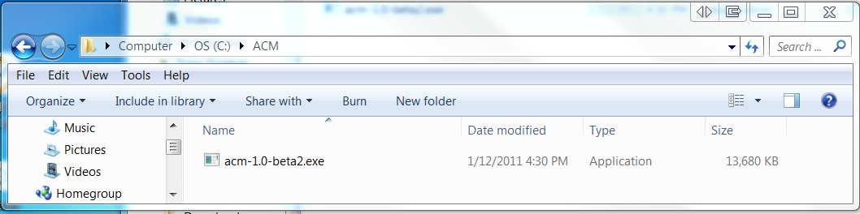

1. Right click the .exe file, and click **Create Shortcut**.

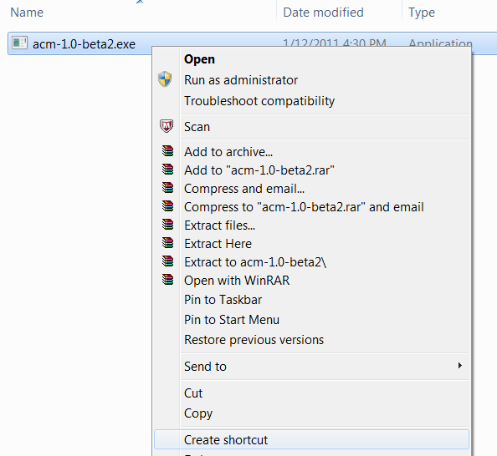

1. Drag the shortcut that you just created from the **C:\ACM** folder onto your desktop or to the task bar on the bottom of your screen.
2. Double-click the shortcut, and click **Run**.

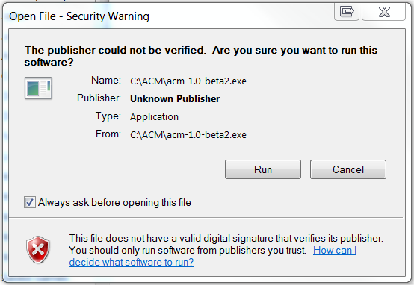

1. Wait a few moments, and ACM will open.

### How to put the Talking Book into USB mode

USB mode is when you can view the files that are stored on the device by connecting the device to a computer using a USB cord. When you connect a Talking Book, it will appear just like a removable disk (“pen drive” or “thumb drive”). USB mode is helpful when you need to perform advanced tasks on the device, such as reformatting it or configuring it with specific messages using ACM.

1. Connect the Talking Book to a computer using a USB cable.
2. If the device does not appear as a drive on your computer within a few seconds, you can force it into USB mode by turning the device off (see “How to turn the device on and off”). Then, press and hold the star  and then press the center button  to turn the device on. Hold the star  until you see a solid red light.

### How to add messages to the Audio Content Manager from a device

Now that you have installed the ACM on your computer, you are ready to begin adding messages to it. Note that the ACM acts like a library that you will use to store all of the messages that you want to use in all of your programs. You can select all or a portion of the messages to add to each Talking Book that you have.

The following procedure explains how add messages to the ACM and then how to add a portion of the messages to a Talking Book.

1. Record messages onto a Talking Book in the appropriate category.
2. Connect the Talking Book to a computer that has the ACM installed (see “How to put the Talking Book into USB mode”).
3. Open ACM (double click on the .exe and then click Yes to continue).
4. In the left hand pane, locate the box titled **Devices**. You should see an entry representing the Talking Book you connected (with a drive letter like “E:” or “F:”). Double click the listing.
5. A window will appear that lists all of the messages that are on the Talking Book.
6. Check the boxes next to the messages that you wish to import and click the **Import** button.
7. Wait while ACM imports the messages. When ACM is finished, all of the messages will appear in the list of messages and they will be sorted into the correct categories.
8. Disconnect the Talking Book

### How to sort and filter messages by category, language, or keyword

The ACM will display all of your messages together in the same main window, but it offers a few ways to easily find the recording you are looking for.

* Click on the label at the top of any column (e.g. “Title”, “Categories”, “Language”, or any of the statistics columns) to sort the messages in alphabetic or numeric order.
* Check one or more boxes in the Categories or Languages panes to filter the main window to a list that only includes messages with those criteria. Uncheck all boxes to return to the full list.
* Type in a word or part of a word in the Search box in the upper-right corner to filter the main window to a list that only includes messages with those characters in the title or other description.

### How to listen to a message in the Audio Content Manager

* Double-click the message;
* Or, click the message to highlight it and press the play button .

### How to edit the title and other message properties

1. Click on the wheel Picture 10 or right-click a message’s row after it is highlighted.
2. Then select the “Edit…” option.
3. See the pop-up “AudioItem Properties” window.
4. Select a cell in any row in the Value column and type a new value (e.g. add a title to your message by clicking the Title row under the Value column).

**Note:** Some values cannot be changed (e.g. Identifier and Source)

1. Close the window by clicking the **Close** button at the bottom of the window.
2. The values are immediately saved and will remain as part of your ACM library. To make those properties become part of the message as stored on a Talking Book, you must now add the message to a device (see “How to add messages to a device from the Audio Content Manager” below).

### How to copy messages from the Audio Content Manager to your computer’s desktop

* To copy a single message from the Audio Content Manager to your computer’s desktop, click on the wheel Picture 10 or right-click a message’s row after it is highlighted. Then select the “Export…” option. You will then be asked to select a directory where the file will be copied.
* To copy multiple messages from the Audio Content Manager to your computer’s desktop, highlight all the messages you want to copy (they must be adjacent messages) and right-click them. Then select the “Export…” option, which will indicate the number of messages you have highlighted. You will then be asked to find the folder where the files will be copied.

Description: http://t1.gstatic.com/images?q=tbn:jeTJ7rxyK5nS4M:http://rlv.zcache.com/exclamation_point_sticker-p217263172132151285qjcl_400.jpg**Important**: Do not type a filename in Export pop-up window. Just select the folder where you want the messages to be copied. The original filenames will be used.

### How to add messages to a device from the Audio Content Manager

1. Connect a Talking Book to the computer (see “How to put the Talking Book into USB mode”).
2. When the new Talking Book appears in the **Devices** pane, double click the drive letter associated with it.
3. Unless you wish to add messages from this device to the ACM, cancel the import window.
4. Drag one or more messages from the main ACM window onto the Talking Book listed in the **Devices** pane.
5. Watch for the “exporting” window, and wait until it disappears.
6. Repeat steps 4 and 5 until you have copied all the messages you desire.
7. Disconnect the Talking Book. You will now be able to listen to the new messages on the device.

### How to delete messages from the Audio Content Manager

* To delete a single message from the Audio Content Manager, click on the wheel Picture 10 or right-click a message’s row after it is highlighted. Then select the “Delete…” option. You will then be asked to confirm you really want to delete the message. Once you do, it cannot be recovered.
* To delete multiple messages, highlight all the messages you want to delete (they must be adjacent messages) and right-click them. Then select the “Delete…” option, which will indicate the number of messages you have highlighted. You will then be asked to confirm you really want to delete all the messages. Once you do, they cannot be recovered.

### How to view message usage statistics and survey results

Any Talking Book contains information about how many times each message on it has been listened to or copied and how users have answered survey questions about it. Each time you open the ACM’s Import window for a Talking Book (see “How to add messages to the Audio Content Manager from a device”) all the usage statistics and survey results on that device (including statistics from other devices that it has connected to) are used to update the ACM’s counts.

**Note:** A Talking Book’s statistics files are not updated until it is shut off. This means that the counts associated with operation during its current “on cycle” will not be updated if the device is connected to an ACM before it has a chance to go to sleep or is manually shut off.

The six statistics columns provide the following information:

* **Open:** the number of times the message was played for more than the first 10 seconds.
* **End:** the number of times the message was played through to the end.
* **Copy:** the number of times that the message was copied from one device to another
* **Survey:** the number of times that a user selected the option to take a survey about the message
* **Apply:** the number of times that a user responded to the survey that they intended to apply some of what they learned from the message
* **No Help:** the number of times that a user responded to the survey that the message was not very helpful to them

## Advanced Tasks

### How to create an outbox folder

Creating an outbox folder on a Talking Book allows that device to easily update other devices with new messages or operating system updates. See “How to update a device and retrieve its user feedback and statistics at once” above.

**Note:** If Literacy Bridge has sent you a .zip with a folder named **outbox**, there is no need to follow this procedure. Simply copy the **outbox** folder to a Talking Book so that it is adjacent to the **inbox**, **messages**, **system**, and **languages** folders.

To create an **outbox** folder with a set of messages to later be copied to other devices:

1. Follow all steps in “How to add messages to a device from the Audio Content Manager” except the last step. Do not disconnect the Talking Book yet.
2. Click **My Computer**, and double click the device.
3. Right-click on the **inbox** folder and select “Copy”.
4. Click on any part of the window containing the **inbox** folder without clicking on the other files or folders. Then right-click and select “Paste”.
5. Right-click on the new folder named “Copy of inbox” and select “Rename”.
6. Rename the folder to **outbox**.

Now all the messages that you selected in step 1 will be ready to be copied to any other device using the steps described in “How to update a device and retrieve its user feedback and statistics at once”.

### How to reformat a Talking Book and apply a new operating system

This procedure assumes that you received an .img (for example, r790.img) and a .zip file from a staff member at Literacy Bridge. These files together contain all of the content needed to reformat a device—including the audio system messages, individual messages (if there are any), as well as the firmware that tells the Talking Book how to function correctly. Use the following procedure to update a Talking Book with the new files. Be aware that this will delete all content that is currently on the device.

1. Take the gray rubber band off of the Talking Book and connect it to the computer using a USB cord.
2. The device will appear as a drive after 3 seconds or so. To view the drive, click My Computer, and you will see the new device (for example, **Removable Disk (E:)**).
   1. If the device does not appear as a disk, you can also press the star button while you turn it on, which will force the device into USB mode immediately.
3. Right click the device (for example, **Removable Device (E):**) and click **Format**.
4. Change the **File system** to **FAT32** (see the figure, below), click **Start**, and click **OK** if you receive a warning.

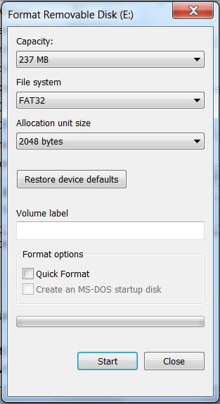

1. When you receive a message that the format is complete, click **OK** in the message box. Then click to close the **Format** dialogue box.

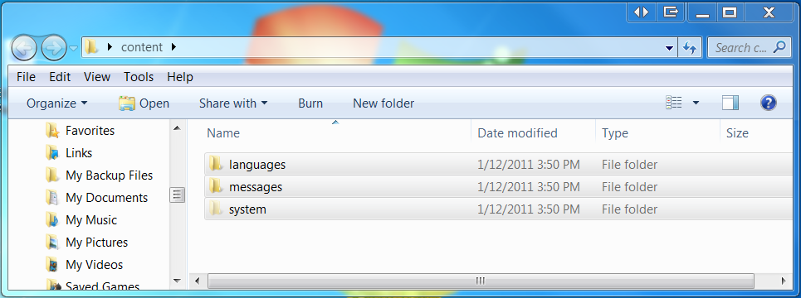

1. Open the .zip file. Press **CTRL+A** to select all of the contents within the .zip file (e.g. folders titled **languages, inbox,** **messages,** and **system** and possibly a .img file).
2. Double-click the device (Removable Drive E.) and you will see that there are no files in the device.
3. Drag the files from the .zip file (all three folders) into the device. It might take several minutes for Windows to copy all of the files.

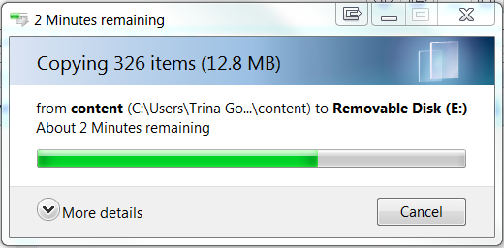

1. When all of the files are copied, it should look like the following diagram.

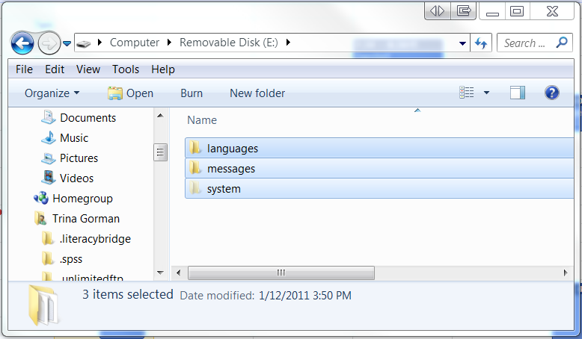

1. Close the window for the device by clicking the X in the upper right corner.
2. Safely remove the device.

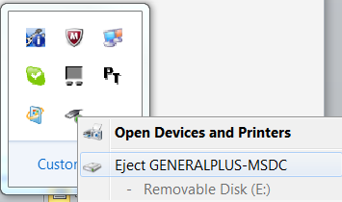

1. Disconnect the device from the computer using the USB cord.
2. Before you turn on the device, note the following important information: it takes 45 seconds to initialize the device when you first turn it on after reformatting it. When you turn it on for the first time, you will hear a bit as the software processes take place. It is critical that you do not take out the batteries or unplug the device from USB from the computer as this happens.
3. Turn on the device. When it turns on, it will beep twice and you must wait until you hear the “Welcome”.
4. You are now ready to use your newly formatted Talking Book.

### How to add a category to a Talking Book

**Note**: This procedure will soon be replaced in a future Talking Book operating system with a method of adding categories from the device’s user interface.

**Note:** This procedure describes how to configure a device so that it includes a category that is already registered as part of the Talking Book system (those viewable in the ACM’s category pane). To create a new category, please contact Literacy Bridge so that it can be assigned a universal category identification number.

1. Connect the device to your computer and place into USB mode (see “How to put the Talking Book into USB mode”).
2. Click **My Computer**, and double click the device.
3. Open the **messages** folder on the device.
4. Open the **lists** folder.
5. Open the **lb_taxonomy.yaml.txt** file. Browse this file to find the category that you want to add by looking at the text following “name:”. Once you find the categories you want to add, note the number(s) for each one, listed on the line immediately before the “name:” line (e.g. “2-3”).
6. Open the folder named for the language of the operating system you want to configure (e.g. “EN” or “TW”).
7. Open the **_activeLists.txt** file. This file lists the category codes for each category that will be listed on the device for the selected language.
8. Type the numbers for each category that you want to add, inserting the numbers in the same order that you want it to be presented in audio form.
9. Save the **_activeLists.txt** file.
10. Safely remove the device.
11. Disconnect the USB cord from the device.
12. Start the device in the selected language and notice the new categories are listed.